Air Quality Social Media Post Content

Each graphic is for a different level of air pollution that will be indicated in all Air Quality Alert communications from MORPC.
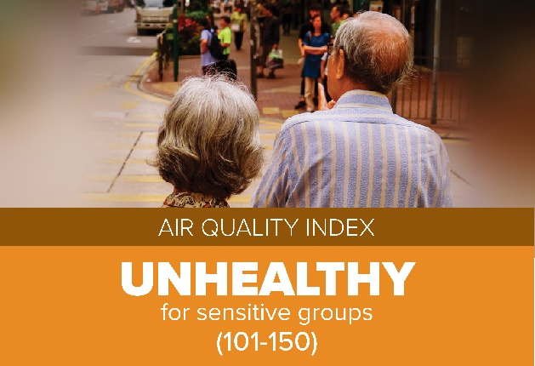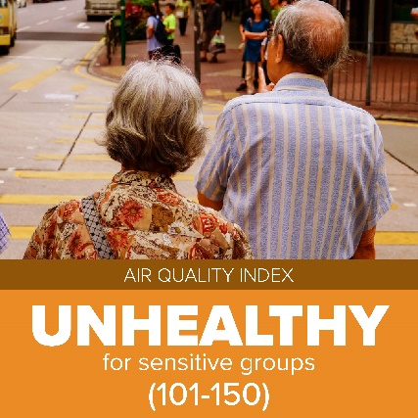
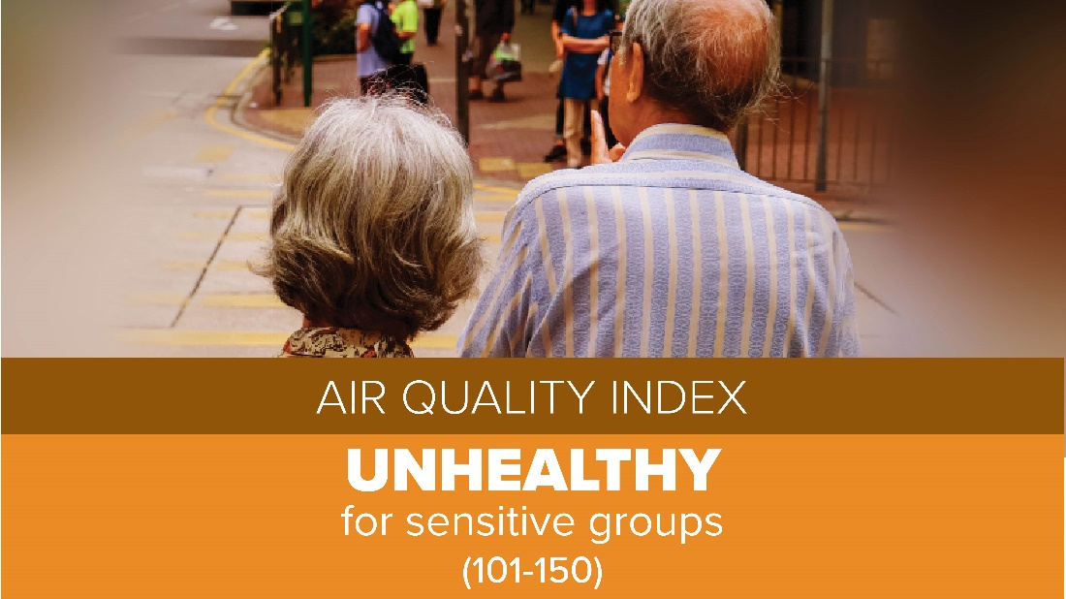

Facebook Copy:
Today is an Air Quality Alert day in Central Ohio.
To decrease the potential for health issues, sensitive groups of people (children, elderly, people with COPD or asthma) are urged to limit prolonged or strenuous outdoor activity.
Visit www.morpc.org/airquality for more information and to sign up for free alerts by email or text.
Twitter Copy:
Central Ohio is under an Air Quality Alert today. To decrease the potential for health issues, sensitive groups of people (children, elderly, people with asthma or COPD) are urged to limit prolonged or strenuous outdoor activity. Visit morpc.org/airquality
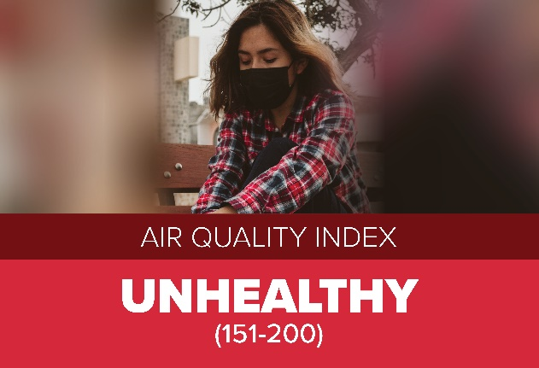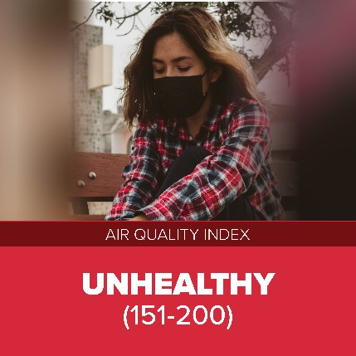
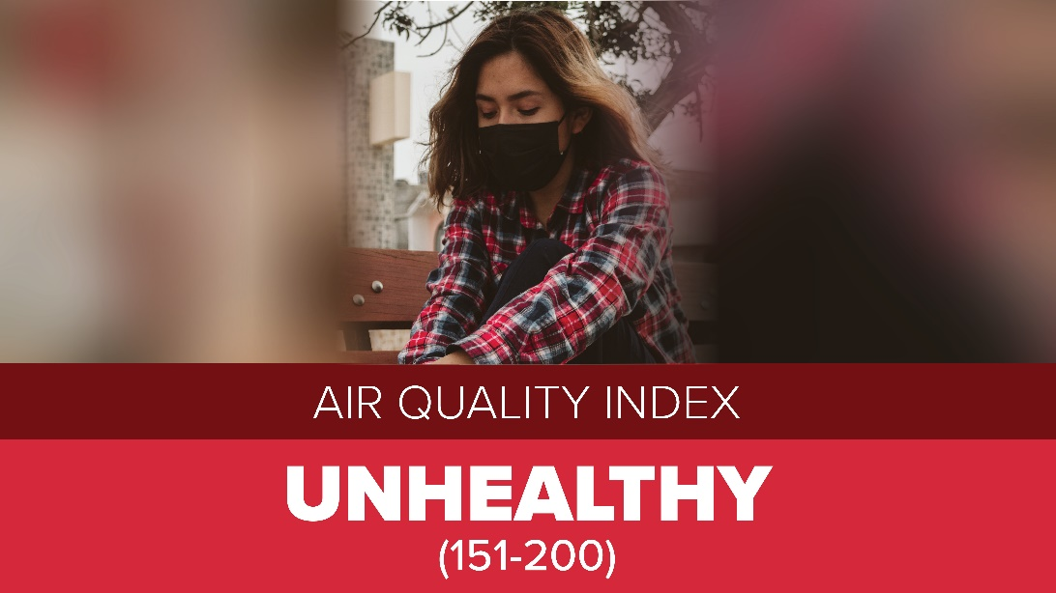
Facebook Copy:
Today is an Air Quality Alert day in Central Ohio.
To decrease the potential for health issues, everyone is urged to limit prolonged or strenuous outdoor activity.
Visit www.morpc.org/airquality for more information and to sign up for free alerts by email or text.
Twitter Copy:
Central Ohio is under an Air Quality Alert today. To decrease the potential for health issues, sensitive groups should avoid prolonged or strenuous outdoor activity and everyone should limit prolonged or strenuous outdoor activity. Visit morpc.org/airquality

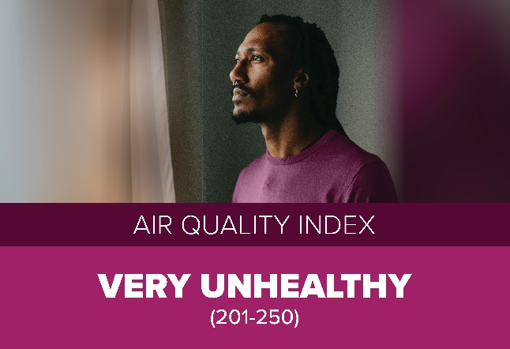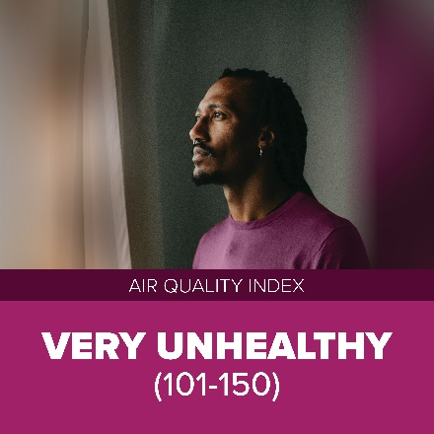
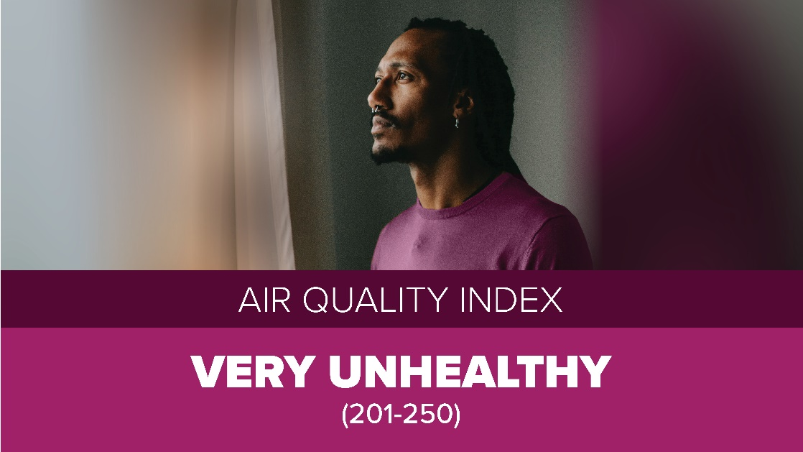
Facebook Copy:
Today is an Air Quality Alert day in Central Ohio.
To decrease the potential for health issues, sensitive groups of people (children, elderly, people with COPD or asthma) are urged to avoid all outdoor activity and all others should limit their outdoor activity.
Visit www.morpc.org/airquality for more information and to sign up for free alerts by email or text.
Twitter Copy:
Central Ohio is under an Air Quality Alert today. Sensitive groups of people (children, elderly, people with asthma or COPD) should avoid all outdoor activity. Others should limit outdoor activity. morpc.org/airquality

