MORPC TMC Format

Turning Movement Counts
A turning movement count shall be converted to an Excel spreadsheet with two tabs named “Cars” and “Trucks”, as shown in Table 1 and 2 (MORPC Turning Movement Count Data Collection Template), separately. If no truck counts are required, only Tab “Cars” is required to store vehicular counts, and Tab “Trucks” shall be left as blank for all the count cells. If truck counts are required, Tab “Cars” shall be used to store car counts, and Tab “Trucks” shall be used to store truck counts. The spreadsheet includes four approach fields such as Southbound, Westbound, Northbound, and Eastbound. Turning movements should be collected from all approaches including driveways that act as an approach (e.g., parking lot entrances). As shown in Table 1 and 2, data should be summarized in 15-minute increments throughout the count period (usually 6-24 hours).

Table 1: Turning Movement Count Standard Format for Cars – Tab “Cars”
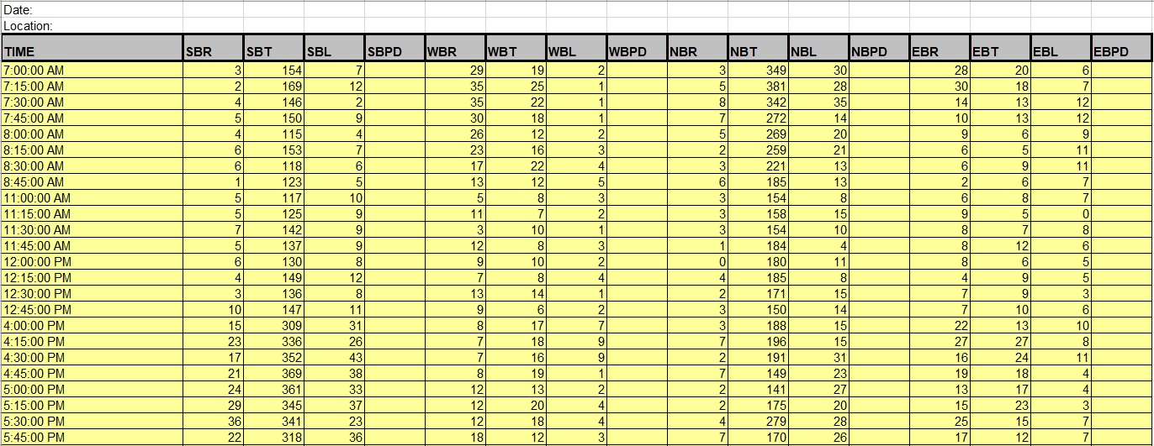

1. Location: A description of intersections and any land marks, and major businesses adjacent to.

2. SBPD, WBPD, NBPD, EBPD: Fill out these columns if pedestrians’ count requested.

Table 2: Turning Movement Count Standard Format for Trucks – Tab “Trucks”
